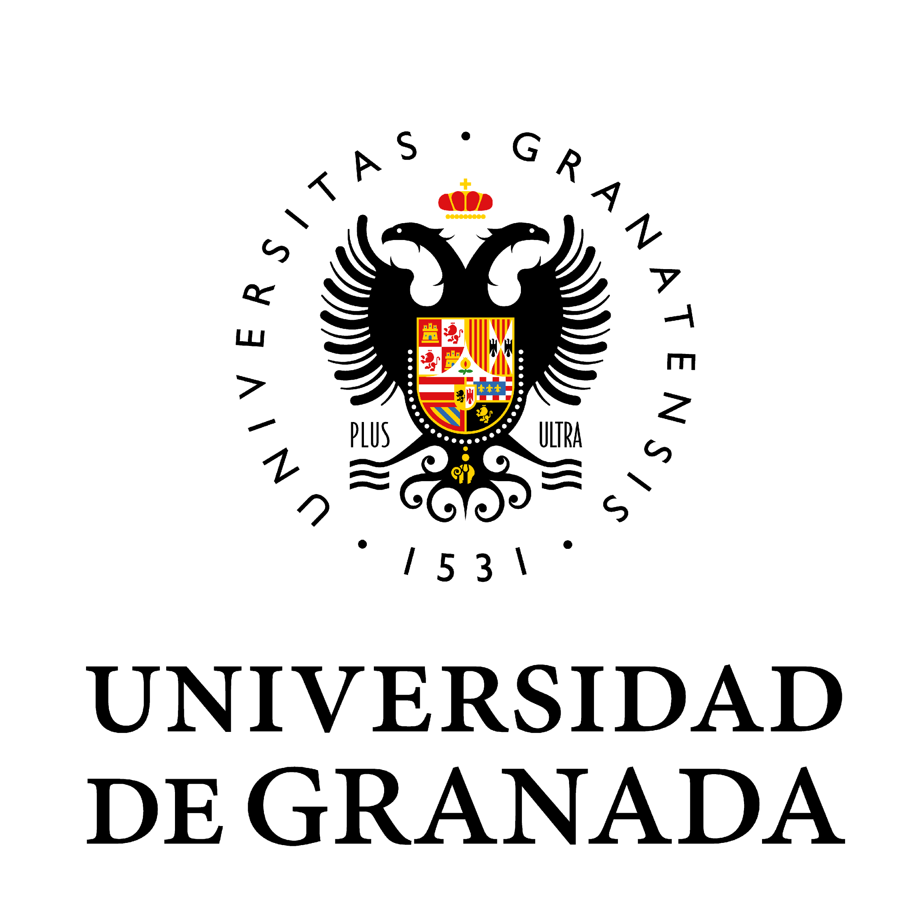

LOSS OF DOCTORAL DEGREE CERTIFICATE

Mr/Ms ………………………………………………………………….…….…….., with DNI/NIE/Passport …………………………,
born on ……………………………............in …………………………………………..…..…..………,
province of …………………………..., with address at ……….……………………………..………..…..
no. …….…., flat no. …….., located in ………………………….…………………, province of …………………….
Post Code …………… Telephone no. …………………. Mobile no. ………………….…..
E-mail ………………..………………………………………………………

HEREBY STATES

That their official university degree certificate in …………………………………………………………………………………………………………………..…………………, valid throughout Spanish territory, has been lost
and that, in accordance with the Order of 8 July 1988, they must undertake the necessary procedures prior to sending the announcement of the loss of degree certificate to the Official State Gazette (BOE).

HEREBY REQUESTS

To be provided with the text of the BOE announcement and the applications for self-assessment and refund.

Town/City .............................. Date ......../........./.......... |  | Signature:

Bank details to be provided by the applicant (these details are essential; the fees cannot otherwise be refunded in the event that the announcement is not published).

Bank |  |  |  | Branch |  |  |  | Check Digits |  | Account Number

RECTOR OF THE UNIVERSITY OF GRANADA

